# Top 10 Best SmartWatches To Choose From (2015)

## Smart Watch Review

Smartphones allow easy connectivity & greater access to information in public places where you can just take a glimpse of your watch, have your notifications or vital information delivered to you in an instant.

Checking Game scores, weather, traffic, directions, quick messages, fitness tracker, silent alarms are just a fraction of the applications what a SmartWatch can do & were designed in regards with the hardware & software combination.

From its inception 2013, key companies like Pebble, Motorola, LG made some notable contributions regarding improving Smart Watch designs, power, Functions leading to good time for buying a SmartWatch in 2015.

* **Compatibility**

When buying SmartWatches the user should concern with the SmartWatch OS compatibility, for better end results or basic uses of an SmartWatch other than just the Time..!!

Google Wear is a platform for android SmartWatches.

Pebble was the first SmartWatch which made SmartWatches mainstream in daily use.

Windows Phones have Microsoft Band as there SmartWatch .

### Design

There are two types of basic designs which manufactures follow

1) Circular Design

2) Rectangular Design

Other Key factors would be the belt being of Plastic, Leather or Steel.

### Functionality

Regarding the functionality is dependent entirely on the device you pair & the SmartWatch you buy.

Look for potential fitness sensors embedded in the SmartWatch, but in 2015 mostly a significant number of SmartWatches releases come with Basic Sensors like 3-axis accelerometer, Gyroscope, GPS Ambient light sensor.

Always consider the apps you use daily on your Smartphone & check for SmartWatches compatibility with that particular app. Eg. Facebook, Twitter Feed apps on particular SmartWatch.

### Ease of Use

The main feature of SmartWatch is to make technology accessible when you need it in an instant without distraction & cumbersomeness. The SmartWatch UI should be slick & pretty easy to understand for First Time users.

This list will improve the buying decisions regarding SmartWatches in 2015 & making SmartWatch features to get utilize in better way compared to the big brother “SmartPhone”

## Here are the Top 10 SmartWatches worth buying in 2015:

## 10) Samsung’s Gear LiveE:\SensehacK Developer\Writings\BeeBom\samsung gear live.png

This is the least expensive Smart watch in android wear categories available today.

It sports an AMOLED display & also a heart rate monitor included in the Gear Live.

The charging adapter is also different from other smart watches.

Specifications:

OS : Android Wear

Weight: 2.12 oz

Battery: 300mAh

Memory: 512MB RAM, 4GB Internal**

Connectivity: Bluetooth 4.0 LE

Display: 320 x 320pixels 1.63”

Display Technology: Super AMOLED®

Price : Rs.15,900 (Playstore) (https: //play.google.com/store/devices/details/Samsung_Gear_Live_Black?id=samsung_gear_live_black&hl=en)

## 9) Pebble

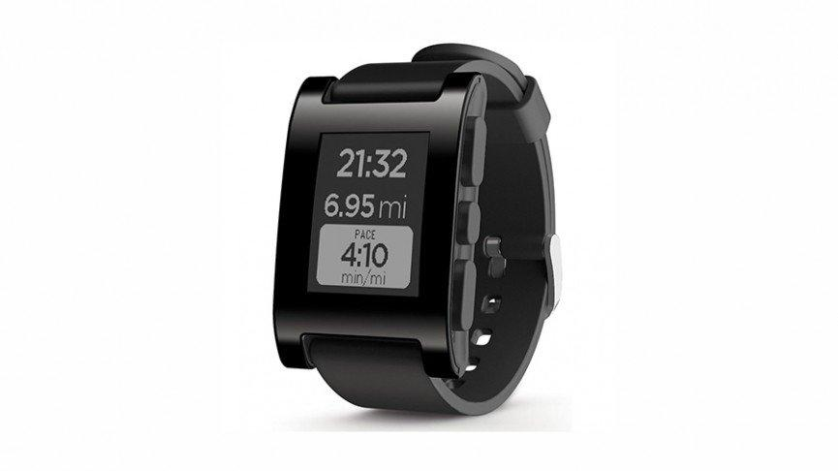

Pebble was the first device which made non-technical users to have a SmartWatch on their wrist. The Pebble has more colour options than any of the competitors but the build quality is plastic. Recently, Pebble have added much some tweaks to their software, which includes Android Wear Support for notifications

Specifications:

OS : Pebble OS

Weight: 38g / 1.34oz

Battery: Up to 7 days between charges

Memory: RAM 128 KB, 8 mib (MB)

Connectivity: Bluetooth 4.0

Display: 1.26-inch, 144 × 168 pixel e-paper display

Display Technology: Super AMOLED®

Sensors: 3D accelerometer, Compass, Light sensor.

Price: Rs.9,764.00/- ([http: //www.amazon.in/Pebble-E-Paper-iPhone-Android-Devices/dp/B00BKEQBI0](http://www.amazon.in/Pebble-E-Paper-iPhone-Android-Devices/dp/B00BKEQBI0))

## 8) Motorola Moto 360

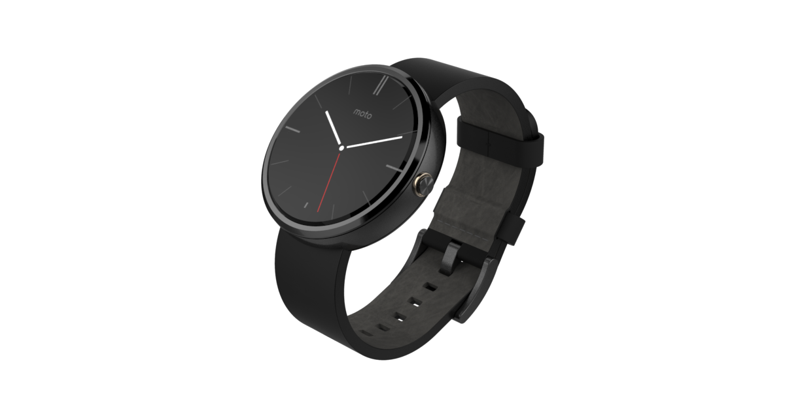

Moto 360 could seriously turn heads, with that Round watch design & luxurious build quality with affordable price tag. You could never go wrong with this SmartWatch.

It deserved Number 3 Spot, but due to its lower resolution, less battery life & black section at the bottom of the screen made us think back about the potential flaws in this product.

This Smart Watch is for the people who love Retro Watches Round Design & black strap are perfect combination of Beauty & Technology.

The watch has Gorilla Glass 3, Heart Rate Monitor & is also Water Resistant

Specifications:

OS : Android Wear OS

WEIGHT: 49 g

Battery: 320 mAh

Processor : TI OMAP

Memory: 512 MB, 4GB internal memory

Connectivity: Bluetooth v4.0

Display: 1.5-inch Display Size” 320 x 290 pixel

Display Technology: Backlit LCD

Sensors : Heart Rate Monitor, Pedometer

Price : Rs.17,999 /- (http: //www.flipkart.com/motorola-moto-360-SmartWatch/p/itmdzrf56agybrvt)

## 7) Microsoft Band

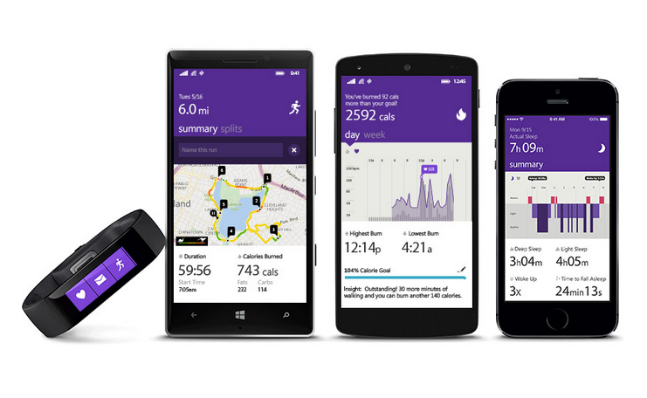

It is the first device from Microsoft & also the first device to support Windows Phones.

This SmartWatch “Band” has different approach in terms of display design . It is neither square nor circle but it in a elongated rectangle which looks like an actual fitness band.

Its small, lightweight & supports all major Smartphone OS. Cortana Personal Assistant of Microsoft is also available for Windows Phone 8.1 users. Some Features require Lumia Denim update.

Microsoft Band is a fitness band created and developed by Microsoft, and released in very limited quantity on Microsoft Store. Its not available in India Yet Officially.

The band supports 10 sensors which includes Optical heart rate sensor , 3-axis accelerometer, Gyrometer, GPS, Ambient light sensor, Skin temperature sensor, UV sensor, Capacitive sensor, Galvanic skin response, Microphone.

The battery life is good with 2 days of normal usage.

More information on ([http: //www.microsoft.com/microsoft-band](http://www.microsoft.com/microsoft-band))

Specifications:

OS : Microsoft's wearable architecture

Weight: 2.12 ounces (60 g)

Battery: 48 hours Dual 100mAh

Memory: 2MB of RAM, 64MB internal storage

Connectivity: Bluetooth 4.0 (Low Energy)

Compatibility: Works with Windows Phone 8.1 update with Bluetooth, iOS 7.1 and later: iPhone 4S, 5, 5C, 5S, 6, 6 Plus and Android 4.3-4.4 phones, with Bluetooth.

Display: Capacitive 1.4" 320 x 106 pixels

Display Technology: TFT full colour display

Sensors: Optical heart rate sensor , 3-axis accelerometer, Gyrometer, GPS, Ambient light sensor, Skin temperature sensor, UV sensor, Capacitive sensor, Galvanic skin response, Microphone.

Price: $199

## 6) Pebble Steel

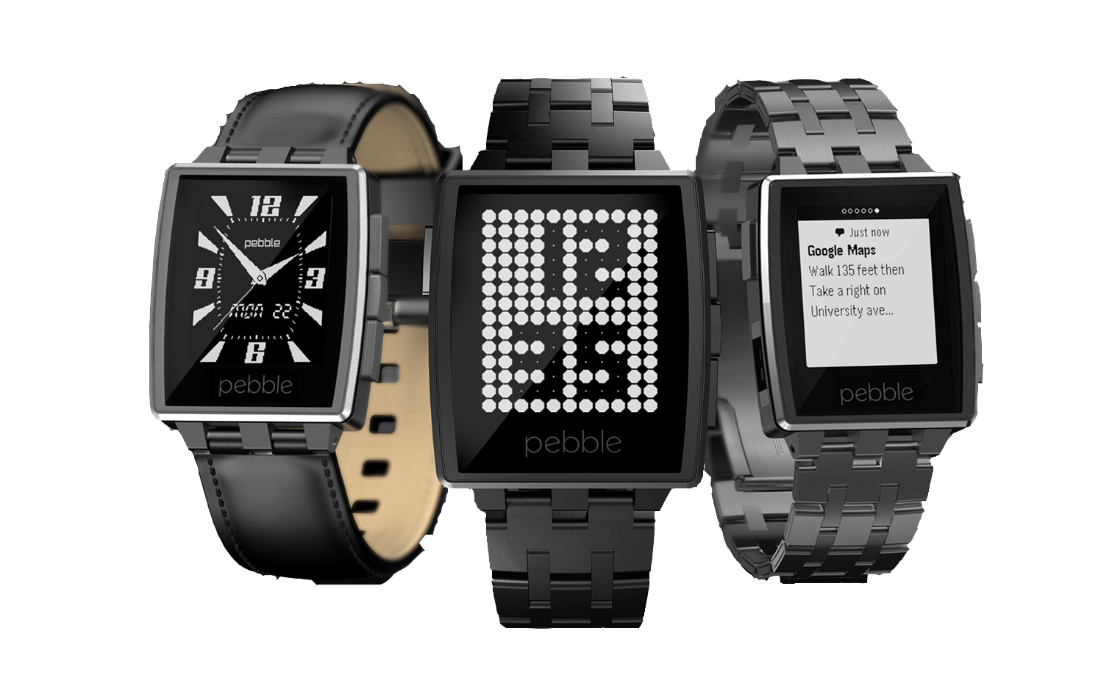

Pebble Steel lacks a high resolution screen or colourful display & that square design may not be appealing to everyone but the build quality just screams Premium & it also provides excellent battery life.

Choose this SmartWatch if Android Wear is not your cup of tea or if you want more device compatibility.

Specifications:

OS : Pebble OS

Weight: 56g / 1.97oz

Battery: Up to 7 days between charges

Memory: RAM 128 KB, 8 mib (MB)

Connectivity: Bluetooth 4.0

Display: 1.26-inch, 144 × 168 pixel e-paper display

Display Technology: LED backlight

Sensors: 3D accelerometer,Compass,Light sensor.

Price : Rs.21,990/- (http: //www.amazon.in/Pebble-iPhone-Android-Devices-Leather/dp/B00IVX0XGO)

## 5) Samsung Gear 2

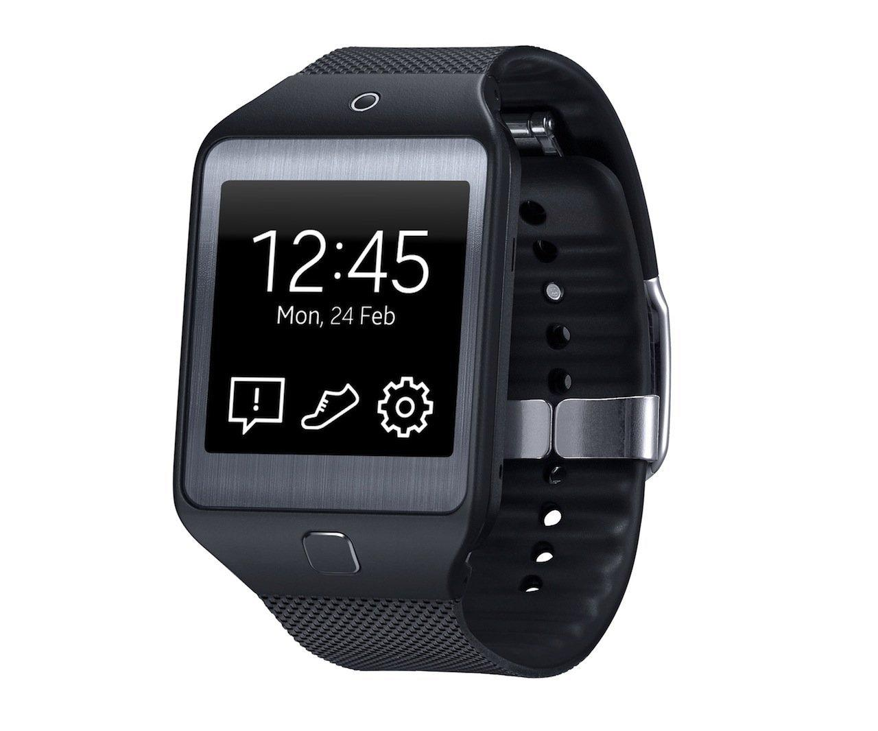

Samsung Gear 2 was announced at the same event as the Galaxy S5 & the biggest pain with this device is it won’t work with any other Smartphone other than a Samsung Smartphone, but still the offering by this SmartWatch is a great must have accessory for die-hard Samsung fans.

This SmartWatch has an integrated Camera which is what makes this SmartWatch different from its competitors. Not that the Camera on SmartWatch would be useful in everyday scenario but still it has one. It also comes with range of Sensors most useful would be Heart-rate sensor,

With a camera, heart-rate monitor and some other interesting features, Featuring a built-in microphone and speaker .Other features include a built-in heart rate monitor and integrated camera.

OS : Tizen

WEIGHT: 2.12 oz

Processor: 1.0 GHz dual-core Exynos 3250

Battery: 2~3 days

Memory: 512MB RAM, 4GB Internal**

Connectivity: BLUETOOTH 4.0 LE

Display: 320 x 320pixels 1.63”

Display Technology: Super AMOLED®

Camera: 2.0 Megapixel Auto Focus

Compatibility: Works with Samsung Smartphones only

Sensors: Accelerometer, Gyroscope, Heart Rate Sensor.

Price : Rs. 28,990 /- (http: //www.amazon.in/Samsung-Gear-2-Charcol-Black/dp/B00O9YS8P2/ref=pd_sim_sbs_e_21?ie=UTF8&refRID=1QX2Q32YH9ZNHSBQND5Y)

## 4) Sony SmartWatch 3E:\SensehacK Developer\Writings\BeeBom\smart watch 3.jpg

Smart Watch 3 from Sony is one of the few watches which has GPS in built, which makes it easily usable for Fitness related apps without having to carry a phone around with you. Still the battery life leaves us lot to be desirable. The new Metal version & strap adapter makes this SmartWatch more appealing than its predecessor.

Specifications:

OS : Android Wear

WEIGHT: 45 g

Battery: 420mAH

Processor 1.2GHz ARM A7 quad core processor

Memory: 512MB RAM, 4GB internal memory

Connectivity: Bluetooth 4.0 Connectivity, NFC

Display: 1.6 inch” 320 x 320

Display Technology: Transflective LCD Display

Price : Rs.16,989/- ([http: //www.amazon.in/Sony-SmartWatch-3-SWR50-Black/dp/B00P7ATIR4/ref=sr_1_1?s=electronics&ie=UTF8&qid=1426053559&sr=1-1&keywords=SmartWatch+3)](http://www.amazon.in/Sony-SmartWatch-3-SWR50-Black/dp/B00P7ATIR4/ref=sr_1_1?s=electronics&ie=UTF8&qid=1426053559&sr=1-1&keywords=smartwatch+3))

## 3) LG G Watch R

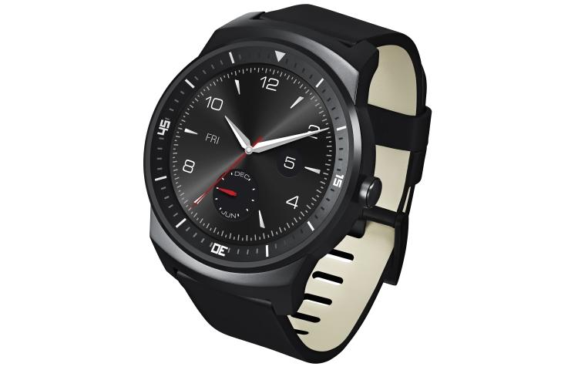

LG G Watch R packs amazing specification & with that round design this watch makes every SmartWatch manufacturer to adapt the round design.

It has full circle display unlike the Moto 360, but the display is so much better than other SmartWatches in comparison. It has better battery life than the Moto 360 thanks to a bigger 410Mah battery & always ON display.

The watch is also pretty light compared to its competitors, it also has dust & water resistant display.

Still it is one of the expensive SmartWatches you could buy. Price : Rs.14,999/-

Specifications:

OS : Android Wear

Processor: CPU Qualcomm® Snapdragon™ 400, 1.2GHz

WEIGHT: 62 g

Battery: 410 mAh

Memory: 512MB RAM, 4GB eMMC (user available memory up to 3 GB)

Connectivity: BLUETOOTH 4.0

Display: 1.3” Full Circle

Display Technology: P-OLED

Sensors 9-Axis (Gyro, Accelerometer, Compass), PPG (Heart rate monitor), Barometer

## 3) Apple Watch

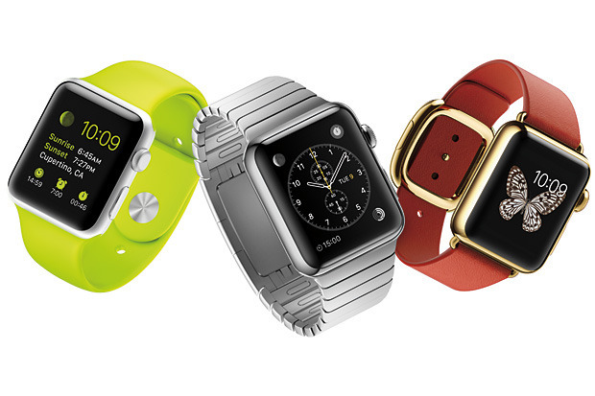

The Apple Watch is available in most of the countries mainly including UK, Australia, China, Japan, Hong Kong, Germany and France.

Three variants of Apple Watch are available :

* Apple Watch Sport
* Apple Watch
* Apple Watch Edition

### Apple Watch Sport

Apple Watch Sport comes with a fluoroelastomer (synthetic rubber) band, and has an aluminum-alloy body (silver or space gray), Ion X-strengthened glass and composite back. It costs $349 for 38mm, or $399 for 42mm sizes.

### Apple Watch

Apple Watch (the mid-tier model) comes in stainless steel with a sapphire crystal and ceramic back. There are two colours (steel and space black steel), and a number of pre-packaged or separately-sold bands. It starts at $549 (38mm) or $599 (42mm). Depending on which one you pick, you could pay anywhere from $549 to $1100.

### Apple Watch Edition

Apple Watch Edition has an 18-karat gold (rose gold or yellow gold) body with sapphire crystal and ceramic back and starts at $10,000, with options ranging all the way to $17,000.

Confusing Right ? Yes there are Three types of Apple SmartWatches, it ranges from $349 all the way up to $17000.

The accessories are also optional with a plethora of interchangeable bands to pick from colours, types, locking systems, materials etc.

Apple Pay is the Feature which makes it unique currently so you can pay at stores without drawing out your iPhone from your pants or bag & simply tag your apple watch just like an id card barcode verification.

It has haptic feedback which is a "taptic engine" that feels like more advanced and subtle vibration just like an actual human touch sensitivity by a finger. It also has a force-sensitive display: press harder, and it will do different things.

Digital Crown would be used for zooming in & out of applications, photos, maps & many more.

For more information,

Apple recently launched Apple Watch 2.0 Devkit & also it will feature full fledged applications for Apple Watch.

One thing is for sure Apple Watch has got the developers support with numerous number of Applications released for that app ranging from Runtastic to 1Password & DayOne. The App Ecosystem would boom pretty much soon for the Apple Watch.

(https: //www.apple.com/in/watch/apple-watch/)

## 1) ASUS ZenWatch

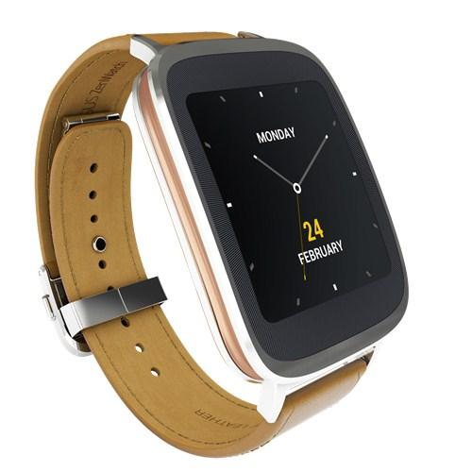

There is nothing wrong with the circle SmartWatch like Moto 360 & LG G Watch R, but the ZenWatch comprises of best aesthetic looks, design, brushed aluminium frame & premium Italian leather watchband which makes the ASUS ZenWatch the best SmartWatch you can buy in 2015.

Metal Strap Fans could easily swap in a bracelet.

It houses Qualcomm Snapdragon 400 1.2GHz which is capable for doing most of the daily computations on a SmartWatch. The display comprises of Gorilla Glass 3 with Water Resistant & AMOLED 1.63"320x320,278ppi Touch Display packed with good battery life makes daily tasks as a breeze.

This SmartWatch would even appeal to the Business class as the build quality is top notch coupled with the leather bracelet, which gives a classic look for Suits & Ties.

Specifications:

OS : Android Wear

Processor: CPU Qualcomm® Snapdragon™ 400, 1.2GHz

WEIGHT: Body : 50 g, Strap : 25 g

Battery: 2 Days (Polymer 1.4Wh)

Memory: 512MB RAM, 4GB eMMC Internal Storage

Connectivity: Bluetooth 4.0

Display: 1.63" 320x320,

Display Technology: AMOLED

Sensors 9 Axis Sensor/Bio sensor.

Price : Rs.22,579/-( [http: //www.ebay.in/itm/like/171670775967](http://www.ebay.in/itm/like/171670775967))

We Hope so, this article would help you decide on which SmartWatch your money can buy with all the proper features for that “Bang for Buck”.

## About the Author

**Kautilya Save**:

Technophile(Geek),Photographer,Enthusiast,Good Managing Sense,Loves Cooking,Enjoys Travelling different places & a Professional Gamer.

Currently pursuing Computer Engineering Degree in D. J. Sanghvi College of Engineering (Mumbai).

Have Passion for Computing & Following Photography as a Hobby.

Gamer Tag : (^$enseh@cK^)

Facebook Link ([https: //www.facebook.com/sensehack](http://sensehack))

Twitter Link (https: //twitter.com/kautilyasave)